THE MEDICAL CENTRE

Heol Yr Onnen, Pencoed: 01656 867900

Practice Website: www.pencoedmedical.co.uk

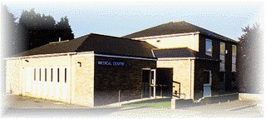

BRANCH SURGERY LLANHARAN

Tredegar Ave, Llanharan: 01656 867900

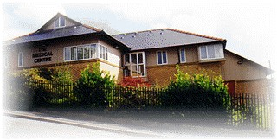

Dr. O Thomas – Dr. E Garfield – Dr. C Priest -Dr. J Crane

Last updated 22.04.2026
Welcome to The Medical Centre
The Practice is a non- limited Partnership

Heol yr Onnen, Pencoed: 01656 867900

Tredegar Ave, Llanharan: 01656 867900

Practice Website: www.pencoedmedical.co.uk

DOCTORS:

Partners

Dr J Anthony Crane MB BCh BSc DCH MRCGP – Male
Qualified at St George’s Medical School 1992. Trained in acupuncture & Member of British Acupuncture Society. Special interests include sports & cardiorespiratory medicine

Dr Owain R Thomas MB BCh MRCGP - Male

Qualified at UWCM Cardiff, Welsh speaking. Special interests includes Cardiology, family planning

Dr Eleanor Garfield MB BCh (Hons) DRCOG DFFP MRCGP – Female

Qualified at UWCM Cardiff 2001. Special interests include family planning and gynaecology

Dr Callum Priest MB BCh MRCGP – Male

Qualified at UWCM Cardiff 2015. Special interests include general medicine, clinical pharmacology and medical education.

Salaried GPs
Dr Nia Williams MBChB MRCGP – Female
Dr Catherine Evans MBCHB MRCGP DRCOG DFSRH - Female
Dr Thomas Davies MBChB – Male
Dr Jordan O’Neill MBChB – Female

Registrars:

The practice is approved as a training practice. There are usually three or four fully qualified doctors with a range of hospital experience attached to the practice for six or twelve months and who are in the process of specialising in primary health care. You may request or be offered appointments with them as well as regular partners and they assist with home visits and clinics. Please consider them as you would one of the Partners.

The Practice may be inspected by other doctors for the purpose of accreditation for training. This may involve inspection of medical records by other doctors. It may, sometimes, be necessary to video consultations with the registrar. The tape would be used for the purposes of training and would only be seen by doctors and personnel who have access to NHS records. We would not video any consultation without informing you beforehand and obtaining your consent.

Nurses:

The practice employs two full time and two part-time nurses who are in attendance each day and are available by appointment.

Their numerous tasks include:

- Minor illness
- Taking blood for tests
- Infant and adult immunisation
- Dressings and removal of stitches, ear syringing, minor injuries
- Care of the elderly
- Health promotion
- INR, asthma and diabetic clinics
- Taking cervical smears and blood pressure

Practice Nurses and Healthcare Assistants:

Sister Lynne Jones RGN NMP – Practice Nurse Manager and Nurse Prescriber. Sister Lynne Jones is the most senior member of our nursing team. Lynne is both a highly experienced Triage Practitioner and a Nurse Prescriber. As well as heading the Nursing Team, Lynne also runs the INR Warfarin Clinic and helps to co-ordinate immunisations and general nursing duties.

Sister Tina Morgan BSc. RGN SPQ Dip DSN – Tina runs our Diabetes and Travel Clinics. If you are travelling abroad and wondering about jabs then you will need to book an appointment in travel clinic well in advance of your journey.

Sister Ellie Wilson MSc BSc NMP SPQ RGN Dip – Ellie is a highly experienced Specialist Nurse Practitioner who covers all nursing duties and is a nurse prescriber. Ellie also runs our Cytology Clinics.

Sister Angharad Rees-Jones BSc RGN – Angharad is our treatment room nurse, and undertakes smears, vaccinations and immunisations and general nursing. Angharad also undertakes our travel clinics.

Mrs Karen Williams and Carys White – Lindsay and Karen perform ECGs, blood pressure, height and weight, administer B12 injections and take blood samples to send off to the laboratory for testing.

Pharmacist:

Sarah Bush is the practice pharmacist, and can help with queries about any medication, undertake medication reviews and prescribe medications. There is usually an additional qualified pharmacist for six months who are in the process of specialising in primary health care. We offer telephone appointments with the practice pharmacists to discuss medication or undertake reviews.

District Nurses:

The District Nurses are employed by Cwm Taf Morgannwg University Health Board. The East Network District Nursing Team are based in Glanrhyd Hospital.

Telephone number: 01656 753495

The geographical areas covered by East Network District Nurses are Llanharan, Brynna, Heol-Y-Cyw, Pencoed, Coychurch, Treoes, and Brackla.

Weekend and Night Cover:

Tel: 111

If you have an urgent medical problem that cannot wait until the Surgery re-opens you should phone 111.

However, for any life threatening emergencies such as chest pain, excessive blood loss, severe breathlessness, you should call 999 in the usual way.

Prescriptions: 4 Ways To Order:

Order Online via the NHS Wales app – You must pre-register for this service. You can find the details on our practice website. You only need to do this once. Once registration is complete you can order online. This is one of the most popular and convenient ways of ordering repeat prescriptions. Remember to allow 3 working days for your order to be processed.

In Person at the surgery – You can hand your repeat prescription slip into the Surgery. Let us know if you would like to pick up the completed prescription from the Surgery 3 working days later or whether you would like us to send the completed prescription to your chosen Chemist by circling the relevant Chemist name on your repeat prescription slip. Prescriptions take 3 working days to process

By Post – Post your completed repeat prescription slip to the Surgery. Remember to indicate whether you would like to collect the completed prescription from the Surgery or whether you would like us to send the completed prescription to your chosen Chemist by circling the relevant option on your repeat prescribing slip

At the Chemist – Some chemists allow you to order your repeat prescription via them. Please speak to your chosen Chemist to see if they offer that service

Practice staff:

Practice Manager – Miss Clare Williams

Clare deals with the business and administration side of running the Practice.

Secretaries - Emma Howells and Mary Thomas

Emma and Mary deal primarily with NHS hospital referrals, results, communications, insurance reports and practice administration duties. If you have made a private appointment to see a specialist Emma and Mary are the people to contact to arrange picking up your referral letter

Reception and Administration

Our excellent reception and administration team are there to help you obtain advice and treatment and are responsible for the smooth running of the surgeries.

Health Visitors:

The Health Visitors are employed by the local Health Board and not the practice. They are based at the Health Centre on Minffrwd Road.

They can be contacted by ringing 01443 803930 or via email at CTM.SPOAHealthVisiting@wales.nhs.uk

Health Visitor for Pencoed: Nikita Griffiths
Health Visitor for Llanharan: Lucy Howells and Amy Johnson

The Health Visitors help with baby clinics, child health and the welfare of our new mothers.

Midwives:

The midwives are jointly responsible with the doctors for the care of patients during pregnancy, labour and after confinement. They help with maternity clinics. The community midwives work on a rota basis.

To register with this service please go to www.ctmuhb.nhs.wales/services/maternity

Visiting the Surgery:

The surgeries are open at the following times:

PENCOED (main surgery): 8.00am to 6.30pm Monday to Friday

LLANHARAN (branch surgery):
Llanharan Medical Centre has limited opening hours. Please visit our Practice Website www.pencoedmedical.co.uk for full opening hours and a list of appointment/clinic times.

Appointments are made via the telephone by ringing 01656 867900 and the following appointments are available to book:

You may pre-book a “routine” face to face appointment with a GP of your choice from 2 weeks in advance, arrange a “soon” appointment within 2 working days with the first available GP or a “book on the day” appointment for new urgent matters that cannot wait.

In addition to these appointments, we offer telephone appointments for patients that would like to have a discussion with a Doctor without attending the Surgery. These appointments are suitable for any problems where there is no need to attend Surgery in person (such as discussion about a result, medication or an enquiry about a health matter). We encourage patients to make use of these appointments whenever possible because it saves you having to come to surgery and often allows the Doctor to deal with more cases than the traditional face to face appointment.

Please note all the appointments detailed above are subject to availability

Mondays are by far the busiest day.

Home Visits: House calls are for genuinely housebound and terminally ill patients only. The Doctor will usually phone to check details of your problem before visiting.

PLEASE PHONE BEFORE 10.30AM WHENEVER POSSIBLE so that the Doctors can allocate house calls efficiently.

Services:

The practice provides full general medical services including:

- Ante-natal
- Family planning
- Cytology
- Child Health Surveillance
- Immunisation
- Health screening
- Minor surgery

Clinics:

Several health promotion and disease management clinics are run in the practice for more efficient care. All are by appointment only and may be varied from time to time according to the needs of the practice.

Please visit our Practice Website www.pencoedmedical.co.uk for full opening hours and a list of appointment/clinic times.

Map of Practice Boundary
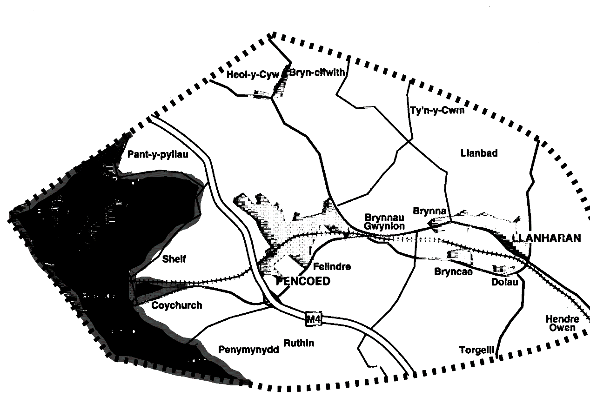

Practice Area

Our Practice area is limited to Pencoed, Llanharan, Brynna and Coychurch. New patients living in these areas can register by calling at reception. We will continue to provide services for existing patients living in Brackla, Coity and Heol-y-Cyw but will not accept new patients from these areas.

Parking at Pencoed:

Patients are requested to park their vehicles in the surgery car park and NOT on the road or in the cul-de-sac, as this causes obstruction and congestion to the adjoining residents. The most accessible route is from the monument via Heol-y-Groes and Ton-y-Groes and bear right into the surgery car park. It must be pointed out that there is no access via Glossop Terrace as this road is marked “Access Only” and this entrance must be kept clear for use as emergency exits by the doctors in the case of urgent calls.

Patient Compliments and Complaints

As a practice, we get many things right, and we also know we don’t get things right every time. We would encourage patients with general compliments or complaints about our service to contact the management team by using the feedback form on our Contact page. But for any genuinely urgent non-medical communication, we recommend that you contact a member of management by telephone.

Disabled patients:

Disabled patients have adequate access at both surgeries.

Self treatment of common illnesses:

Many common aches and pains can be simply treated at home without the need to consult a doctor.

Back pain

Back pain causes 13 million working days to be lost in Britain each year. The spine supports the whole weight of the upper body, so it is understandable that it sometimes goes wrong.

Because of the complex nature of the spine, it is advisable to consult your doctor if back pain persists for longer than a few days. If, as usual, the pain has been caused by abuse i.e. lifting too heavy weights etc., be sensible and take things easy, but remain as active as you can. Take care to sit upright with a support for the small of the back.

Take aspirin or paracetamol, which will not only relieve pain, but will also, help to relieve inflammation.

There is now good evidence to show that inactivity tends to lead to more long-term problems. It seems that the most important thing you can do is to be as active as you can – this will tend to speed your recovery, and it will lead to less long-term problems.

Burns

Apply large quantities of cold water to the affected area as soon as possible and maintain this for as long as 15 minutes. If the skin is unbroken but blistered, apply a loose, dry dressing. If the burn is larger than 4 or 5 inches across, or if the skin is broken, consult your Doctor or go to A&E.

Colds and ‘FLU’

ANTIBIOTICS DO NOT TREAT THE VIRUSES THAT CAUSE COLDS AND ‘FLU’

Go to bed and take plenty of fluids. If you have a headache or are feverish, take aspirin or paracetamol.

We do not, at present, have a cure for the ‘flu’ or common cold. Remember that we can prevent infection for certain groups of susceptible individuals (i.e. the elderly) by immunisation.

You can also ring 111 for further advice.

Diarrhoea

Diarrhoea may be caused by viral or bacterial infections in the bowel. The most important thing you can do is to drink plenty of fluids, since most cases will settle with time. You can drink cooled, boiled water, flat coca-cola or one of the commercial rehydration drinks (e.g. “Dioralyte”).

Be wary of using kaolin & morphine or other constipating agents to stop diarrhoea, because if infection is the cause, they may impair the body’s ability to rid itself of the bugs! Diarrhoea in very young children and babies needs careful attention.

Most babies have loose bowel action during their first 6 months due to their predominantly liquid diet. Sudden bouts of unusually watery diarrhoea should be treated by taking the baby off milk or solids and giving them Dioralyte or a similar product. You could use your own solution made from a pint of boiled cooled water with a teaspoon of sugar and half a teaspoon of salt.

Young babies can become dehydrated very quickly and you should consult your doctor if vomiting, weakness or drowsiness accompanies the symptoms.

Sprains

Remember the word R.I.C.E.!

Rest the affected limb. Apply Ice to the area (or a bag of frozen peas!). Apply Compression with a bandage or support and Elevate the limb (this will help to reduce swelling).

Fever or high temperature

Fever or a high temperature can be a normal response to illness.

Elevating the body temperature may be nature’s way of making our bodies’ environment unpleasant for the bugs that cause disease. Unfortunately, when our temperature rises, we feel unpleasant too!

There are several ways to lower a raised temperature:

- Take paracetamol or calpol regularly, as advised on the bottle
- Drink plenty of fluids
- Remove any clothing or blankets
- Use a fan to cool or open a window. Use a damp flannel to wet the skin (as the water evaporates, it cools the body)If you are worried, contact your Doctor for advice. t bites and stings

Insect bites and stings

Antihistamine tablets can be obtained from the Chemist without prescription and will usually relieve most symptoms.

Bee stings should be scraped away rather than “plucked” in order to avoid squeezing the contents of the venom sac into the wound.

Head lice

These creatures prefer clean hair and are, therefore, not a sign of poor personal hygiene! The safest way to remove them, without side effects, is to use a lice comb. Medicated lotion can be obtained from the Chemist without prescription.

Chickenpox

On the first day, the rash appears as small red patches about 3-4mm across. Within a few hours of these developing, small blisters appear in the centre of these patches. During the next 3-4 days, further patches will appear and the earlier ones will turn “crusty” and fall off.

There is no magic cure. Calamine lotion may be applied to soothe the often severe itching. Cool baths may help. The most infectious period is from 2-3 days before the rash appears until the last of the blisters dries to a scab. Children may return to school after the last of the crusts fall off. Avoid contact with women in the early or very late stages of pregnancy, during the infectious period.

Pregnancy

We no longer routinely test for pregnancy at the surgery. If you suspect that you may be pregnant, we are happy for you to confirm by using a home testing kit or by giving a urine sample to the Chemist for testing.

Remember to start taking 400mcg Folic Acid every day whilst trying to conceive and for the first three months.

There is very clear evidence that smoking and excess alcohol will harm your baby.

Freedom of Information Act 2000
,
As a Practice we are obliged to comply with this act from the 31st October 2003. The act requires every public authority to adopt and maintain a “Publication Scheme” which has been approved by the Commissioner. The Commissioner is the independent supervisory authority appointed by parliament to oversee compliance with both the Freedom of Information Act and the Data Protection Act. The scheme is a guide to the types of information a public authority undertakes to make available to the public as a matter of routine. Our publication is available from the Practice Manager on request.

Confidentiality

Everyone working in the NHS has a legal duty to keep information about each patent confidential. The practice is a data controller under the Data Protection Act 1998 and is registered with the Data Protection Commissioner who ensures that information is kept legally and fairly.

Information about you may need to be shared with other people, e.g registration details with the Business Service Centre at Swansea and Cardiff. In some instances the law requires us to pass on information, e.g notification of birth/death. All persons receiving this information from us will also have a legal responsibility to keep such information confidential.

Your Rights as a Patient

You have a right to see information recorded about you in our manual and computerised records. These rights are incorporated in the Data Protection Act 1998. Information is collected:

- From examinations, observations and tests carried out by staff.
- From what you as a patient or carers tell us.

Information is stored as paper records or on computerised records.

Practice Charter Standards

These are local standards set within the practice for the benefit of our patients. It is our job to give you treatment and advice. Following discussions with you, you will receive the most appropriate care, given by suitably qualified people. No care or treatment will be given without your informed consent. In the interest of your health it is important for you to understand all the information given to you. Please ask us questions if you are unsure of anything.

Our responsibilities to you:

We are committed to giving you the best service.

Names:

People involved in your care will give you their names and ensure that you know how to contact them. The surgery should be well signposted and the doctors’ or nurses’ names are indicated on their surgery rooms.

Waiting time:

We run an appointment system in this practice. You will be given a time at which the doctor or nurse hopes to be able to see you. You should wait no more than 30 minutes in the waiting room without receiving an explanation for the delay.

Access:

You will have access to a doctor or an appropriate member of the practice primary care team within 24 hours. You will be able to prebook an appointment up to 4 weeks in advance. In addition you will have the opportunity to be seen by a GP of your choice within 4 weeks. We will arrange a home visit as appropriate for those who are too ill or infirm to be brought to the surgery.

Telephone:

We will try to answer the phone promptly and to ensure that there are sufficient staff available to do this.

Test results:

If you have undergone tests or x-rays ordered by the practice, we will inform you of the results at your next appointment.

*If no appointment needs to be arranged, please contact the surgery to obtain the results*

Respect:

Patients will be treated as individuals and partners in their healthcare, irrespective of their ethnic origin or religious and cultural beliefs.

Information:

We will give you full information about the services that we offer. Every effort will be made to ensure that you receive the information which directly affects your health and the care being offered.

Health promotion:

The practice will offer patients advice and information on steps they can take to promote good health and self-help for minor ailments when there is no need to see the doctor.

Useful Telephone Numbers:

CTMUHB Out of Hours Service 111

Princess of Wales Hospital 01656 752752

Royal Glamorgan Hospital 01443 443443

NHS BSC Swansea 02921 500200

NHS BSC Pontypool 01495 332000

Citizens Advice Bureau 01656 762800

Age Concern 01443 485505

Police 01656 655555

Bridgend County Borough Council 01656 643643

Rhondda Cynon Taff County BC 01443 424005

Social Services 01656 642279

